1st SCOPE Summer School
August 2-5 2009
Clare College, Cambridge, UK

Information pack
Accommodation

Accommodation onsite at the Summer School venue is available.

- Standard accommodation - 150 Euros for 3 nights
- En Suite accommodation - 225 Euros for 3 nights

To book your accommodation – please complete the registration form and return to the SCOPE office.

All bedrooms are available from 14:00 on 2nd August. Guests are required to checkout by 09:30 on day of departure (5th August).

Breakfast is included in your accommodation, and will be served in the Buttery from 08:00– 09:00.

En Suite accommodation is a bedroom with its own shower room, complete with WC, basin and shower.

Standard rooms all have wash basins but toilet and showers are shared one between every 3-4 bedrooms.

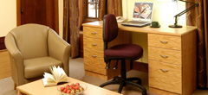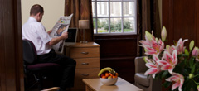

Venue

Clare College is located in the heart of Cambridge and has excellent access to the shops and town centre. Clare College provides modern style lecture theatres alongside traditional buildings and landscaped garden providing the perfect a quiet haven from the surrounding town centre surrounding. For the history of Clare College, please follow the link http://www.clare.cam.ac.uk/about/history.html

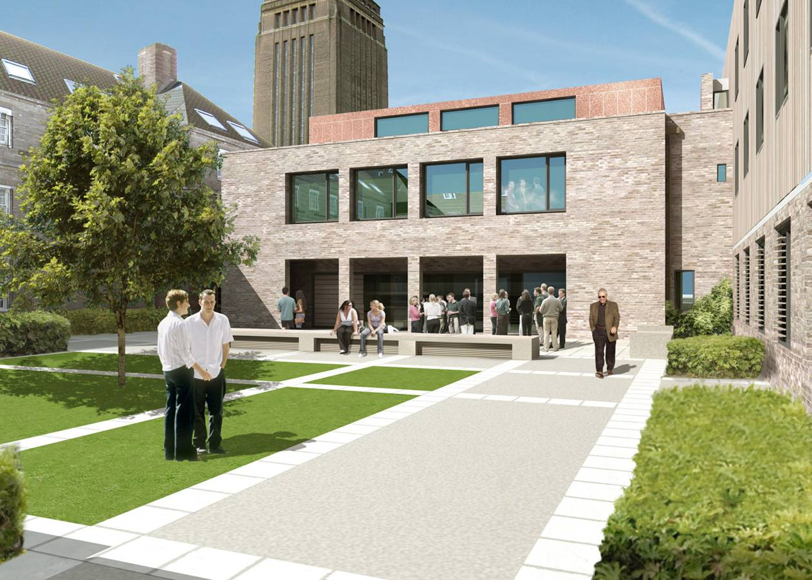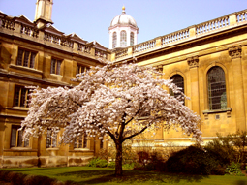

Registration: Registration will be on Sunday August 2nd between 15:30 - 17:00 in the Garden Room, which is located on the ground floor (Lower Lobby) in the main building.

Welcome drinks: will be held in the Scholars Garden on Sunday August 2nd at 18:00.

Lectures: will commence on Monday August 3rd and will be held in the Elton-Bowring Room.

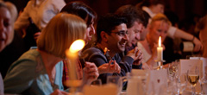
Social Program

The Gala Evening will take place on Monday August 3 and will be held in the ‘Great Hall’. This will be a 4-course waiter-service dinner. Special dietary requirements will be catered for.

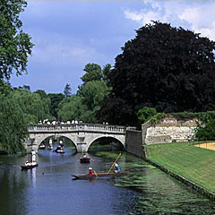

The punts will pick delegates up from the Scholars lawn in the afternoon. The River Cam runs along the back of Colleges and is the perfect way to explore and see the colleges of Cambridge.

How to get to Cambridge

By Road

- Cambridge is linked to London and the M25 by the M11 motorway. Exit at junction 12 for Barton Road or Junction 13 for Madingley Road.
- Access from the Midlands and North is via the A14 and A1. From whichever direction you approach you should make for the A14 to the north of Cambridge.

By Train

Cambridge is less than an hour away from London by train with frequent departures from King's Cross and Liverpool Street stations. Some direct services operate from Birmingham, Liverpool, Manchester and Nottingham. Cambridge Station is about a 25 minute walk from Clare, but buses run every 8 minutes into the centre of Cambridge and taxis are available for hire at Cambridge Station.

By Coach

There are frequent services between London's Victoria Coach Station and Drummer Street Bus Station in Cambridge. Most services will terminate from Cambridge Bus Station, from here it is only a 5-minute walk to Clare Old Court.

By Air

Stansted Airport is located just 30 miles south of Cambridge, and is 35 minutes away via the M11 motorway and is the most convenient international airport and there are regular flights from most European destinations.
Heathrow and Gatwick are both approximately 2 hours away by road or rail, and there are frequent coach connections to Cambridge (Drummer Street Bus Station) from all three airports.

Map of Cambridge http://www.clare.cam.ac.uk/about/map-overview.html

Map of Clare College http://www.clare.cam.ac.uk/about/map-college.html

Pre-reading material

All delegates are required to read the online course manual prior the Summer School. Delegates will be issued with a password to access the online material after their registration has been accepted.

Posters

All students are required to submit a poster when they register. This will cover a topic if interest and will be related and explain your interest in attending the Summer School. These will be viewed by the Speakers during the allocated coffee break poster sessions and will provide an opportunity for delegates to share their work with other attendees and speakers. Please bring your posters with you and your allocated time for presenting your poster will be issued at registration on August 2nd.

Examinations

At the beginning of the course there will be an assessment to assess delegate’s knowledge to help focus the course and highlight areas where delegates may need more time for discussion.

At the end of the course there will be an online test that will assess your knowledge about the lectures taught over the 3-day period. More information will be issued closer to the time.

Additional reminders

- Please ensure that you have adequate travel insurance as this will not be covered by IASO
- Dress code - Dress will be casual for the conference and smart-casual for the dinner
- The currency in the UK is the Pound:
- Visas – Citizens of the EU can visit the UK visa-free for up to 30 days. For residents outside of the EU please check your Visa requirements before you travel
- The official language of the meeting is English – Interpretation facilities will not be provided

 | 2nd August | 3rd August | 4th August | 5th August
08:30–09:00 |  | Pre-test results | Recapture | Recapture
09:00–10:30 |  | Philip James  ‘Obesity in society and prevention’ | Arne Astrup  ‘Energy balance’ | Nick Finer  ‘Treatments for obesity’
10:30–11:00 |  | Coffee break  Poster session 1 | Coffee break  Poster session 3 | Coffee break
11:00–12:30 |  | Philip James &  Caroline Small  ‘Causes of obesity’ | Stephan Jacob  ‘Obesity and co-morbidities’ | All faculty  Chair Stephan Rössner  ‘Long term patient support’
12:30–13:30 |  | Lunch | Lunch | Lunch
13:30–15:00 |  | Group session  ‘Obesity in society and prevention’  Group report | Group session  ‘Energy balance’  Group report | Group session  ‘The clinician’s experience of treatments for obesity, long-term patient support & what works in practice.’
15:00– 5:30 |  | Coffee break  Poster session 2 | Coffee break  Poster session 4 | Coffee break
15:30–17:00 | Registration  Poster mounting  Pre-test  (to be handed in at Cheese & wine) | Group session  ‘Causes of obesity’  Group report | Group session  ‘Obesity and co-morbidities’  Group report | Online exam  Close of Summer school 17.00
18:00 | Stephan Rössner  Welcome  & opening lecture  Cheese and wine |  | Social evening  Punting on the River Cam and international competition for delegates | Online exam  Close of Summer school 17.00
19:30 | Stephan Rössner  Welcome  & opening lecture  Cheese and wine | Banquet in Dining Hall |  | Online exam  Close of Summer school 17.00
SCOPE Summer school program 2009

